Date: April 7, 2021
To: Area Restaurants of Wilson
From: The Arc of Wilson County
Re: 28th Annual Taste of Wilson
Fundraiser for The Arc of Wilson County’s Camp Sunshine

The time is here to prepare for The 28th Annual Taste of Wilson to help fund The Arc’s Camp Sunshine. This is a summer camp for children with intellectual and/or developmental disabilities (I/DD) in Wilson County.

The event will be held on Tuesday, May 25th at The Wilson County Fairgrounds from 5:30 – 8:00 pm or so. The 28th Annual Taste of Wilson will be a drive through event this year. Ticket holders will remain in their cars and drive through the Wilson County Fairgrounds. Restaurants/Vendors will be set up along the path with restaurant staff or volunteers running tastes to the vehicles.

We will be selling a limited amount of 350 tickets this year. We are asking each restaurant to provide 350 tastes so each ticket holder will receive a taste from each restaurant.

Tickets will be sold mostly online through eventbrite and a small amount of physical tickets will be for sale through The Arc of Wilson and its board members. Vehicles will be marked with the amount of ticket holders in each vehicle to assist volunteers in knowing how many tastes to deliver to each vehicle.
We hope we can count on you once more to help us with one of the longest running fundraisers in our community. We truly appreciate your support of this event the past 27 years and we could not do it without you.

You may scan and email, mail, text or call and I will come pick up your form, or you can enter online at www.arcofwilsonnc.org/restaurants

Thank you once again for your support and if you have any questions, please do not ever hesitate to call on me.

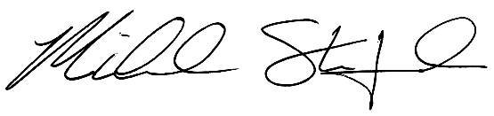
Sincerely,

Michael Stanford,
Executive Director
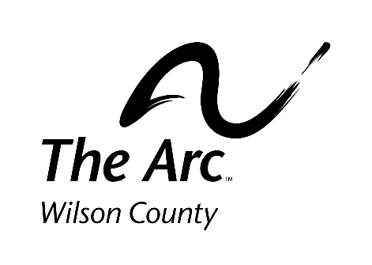

Important information for Participating Restaurants to Keep Handy

- Form/Sign up needs to be complete and submitted by Friday, April 30th
    - If this deadline is not met, the number of participating restaurants will determine if the event is cancelled or not.
- Event Date: Tuesday, May 25th
- Event Location: Wilson County Fairgrounds
- Set up between 3:00-5:15 pm
- Event open for all ticket holders at 5:30 pm
- Participating restaurants/vendors and all event volunteers will abide by all CDC/NCDHHS Guidelines in relation to COVID-19 at the time of the event.

- Samples for 350 people – tickets are limited, and each ticket holder will receive a taste from each participating restaurant/vendor.
- Restaurants/vendors will be present for the entire event.
- All 350 tastes *should* be packaged and ready to serve upon arrival with equipment to keep it at a safe serving temperature.
  - If you prefer to prepare your food on-site, you will have to provide your own food preparation equipment.
  - You will also have to be able to prepare and serve food at a pace to keep the line moving.
  - You will likely be able to arrive and start preparing earlier than the event start time - all of this depends on the weather so we prefer food is ready to serve on arrival.

- Please let us know if you will be bringing a food truck or trailer so we can provide enough space for you.
- The Arc will provide one table to place tastes that are ready and volunteer servers to run food to vehicles if required.
- If possible, provide your own equipment to keep food warm.
- Electricity will not be provided this year.
- Please communicate any additional needs you will require that night ahead of time!
- The Arc will break down tables. Restaurants only need to take out what they brought in. Restaurants can start breaking down once the last ticket holder has received their tastes.

- Feel free to bring coupons, menus, promotional items, etc. to market your restaurant.

The Taste of Wilson Frequently Asked Questions

- Why should I participate?

It helps to promote your restaurant and brings more awareness and business to your establishment. The funds help to provide programs for all persons with intellectual or developmental disabilities in our community. This is a great time to promote any new items on your menu or great items many people may not realize you offer.

- What does it cost me?

Only the cost of the 350 food samples you provide. For Example: Pizza places give a small slice of pizza, Sub restaurants give part of a sub sandwich; some give a small dessert. Anything you feel may be different that will attract business for you. You are only expected, by us, to give a “taste”.

- What do I have to do?

All you are required to do is prepare and package your food. Volunteers will run packaged tastes from your area to the vehicles in line. You can make your area stand out however you wish with a promotional tent, banners, or decorations or attach anything on your packaged tastes such as any information/flyers/coupons to promote your business.

- How does this support The Arc of Wilson County?

This event, through ticket sales and sponsor fees raises the needed funds for Camp Sunshine. This is a summer camp program for children in Wilson County with Intellectual and Developmental Disabilities. Camp Sunshine is a one-of-a-kind summer camp for children with I/DD in Eastern NC!

- What if I’m unable to participate?

No worries! We understand 2020/2021 has been rough on many small businesses and restaurants so we will not hold it against you if you are unable to participate. We certainly hope you are able to come by as a ticket holder or if you are interested in being an event sponsor for a monetary donation, visit our website or call The Arc for more information. www.arcofwilsonnc.org/sponsors or (252) 237-8266

Complete and turn in no later than: April 30 at 12:00 pm
Form can be completed on our website:
www.arcofwilsonnc.org/restaurants
The sooner you register, the sooner we can advertise your participation!
Restaurant:
28th Annual Taste of Wilson
Tuesday, May 25, 2021
Wilson County Fairgrounds
5:30-8:00pm
Contact Person:
Telephone:
Mailing Address:
Email:
Website: Facebook: fb.com/
Instagram: @ Twitter: @

Please check the applicable spaces below:
Volunteer Food Runners: The Arc will provide 2 food runners for each restaurant if requested. Food runners will be responsible for delivering tastes from the restaurant/vendor area to the vehicles in line.

How will your area be set up? (Check all that apply)
Food Truck
Food Trailer ( towing vehicle staying attached)
Bringing our own tent

By completing and signing this form, you agree to:
- Provide 350 tastes to serve to each ticket holder.
- Abide by all CDC/NCDHHS COVID-19 guidelines at the time of the event.
- Be set up and be prepared to serve by 5:20 PM
- Bring all tastes packaged and ready to serve OR to prepare and package all tastes on site at a speed to keep the line moving.
- Acknowledge that set up can begin at 3:00 pm on the day of the event.
- Acknowledge that electricity will not be provided on site this year.
- restaurant participants and volunteers shall always exhibit professional manners.
- Authorize The Arc of Wilson County to post pictures of myself, any restaurant employees/volunteers on hand and my restaurant booth on The Arc’s Social Media sites.

Restaurant
Please complete and return to The Arc of Wilson County by April 30th.
Email: director@arcofwilsonnc.org Mail: PO Box 3943 Wilson, NC 27895
Online: arcofwilsonnc.org/restaurants Call or text for Pick up: 252-237-8266

Representative
Signature: Date:

